📘 DAY-5 FULL DOCUMENTATION
Advanced UI, State Management & E-Commerce Cart Implementation
Name: Yaramala Karthik Reddy
Role: Frontend / React Intern
Day: Day-5
Technology Used: React JS, JavaScript, CSS, Public APIs
1. Objective of Day-5
The objective of Day-5 is to gain hands-on experience in building real-world UI features using React, focusing on:
- Advanced UI components
- Global and shared state handling
- Real-time API integration
- Shopping cart logic
- UI polish and animations
- Debugging using console logs
2. Topics Covered on Day-5
The following topics were implemented practically:
- React Portals & Modals
- Responsive Navbar
- Context-level State Thinking
- Drag & Drop using Public API
- Shopping Cart Logic
- reduce() for Cart Totals
- Cart Drawer (Animated)
- Checkout Modal
- Cart Persistence using localStorage
- UI Polish & Animations
3. React Portal & Modal
What Was Implemented
- A modal rendered outside the main React root using React Portal
- Portal root centered properly
- Console logs used to track mounting and unmounting
Key Learning
- Portals help render UI elements like modals outside the DOM hierarchy
- Useful for popups, dialogs, and overlays
4. Responsive Navbar
What Was Implemented
- Header with site title
- Cart icon positioned at the top-right
- Live cart item count
- Responsive behavior for mobile and desktop
Key Learning
- Responsive UI improves usability across devices
- Navbar layout adapts using CSS and state
5. Public API Integration
API Used
DummyJSON Products API
https://dummyjson.com/products
What Was Implemented
- Products fetched dynamically from API
- Displayed in a responsive grid layout
- Realistic product data (title, price, image)
Key Learning
- Handling asynchronous data using fetch
- Managing API data in React state
6. Drag & Drop (Real-Time Data)
What Was Implemented
- Drag and drop reordering using API-fetched data
- Console logs for drag start, drag over, and drop events
Key Learning
- Understanding HTML5 Drag & Drop events
- Updating UI state based on user interaction
7. Shopping Cart Application
Core Features Implemented
- Add product to cart
- Increase / decrease quantity
- Remove product when quantity reaches zero
- Cart updates in real time
Key Learning
- Managing complex state updates
- Writing clean cart logic
8. Cart Totals Using reduce()
What Was Implemented
- Single reduce() used to calculate:
  - Total items
  - Subtotal
  - Grand total
Key Learning
- reduce() efficiently converts an array into a single value
- Industry-standard approach for cart calculations
9. Cart Drawer (Animated)
What Was Implemented
- Cart opens as a drawer sliding from the right
- Background overlay added
- Smooth animation using transform
Animation Policy Applied
- Hardware-accelerated animations
- No layout shift
- Smooth open and close (300ms)
Key Learning
- Real e-commerce sites use drawer-style carts
- Animations should be smooth and non-blocking
10. Checkout Modal
What Was Implemented
- Modal opens on checkout
- Confirmation message shown
- Cart cleared after checkout
Key Learning
- Modals improve user flow
- Checkout feedback is important for UX
11. Delivery Charges & Cost Breakdown
What Was Implemented
- Product unit price displayed
- Item-wise total shown
- Delivery charges added
- Final payable amount calculated
Example Logic
- Subtotal + Delivery Charges = Grand Total
Key Learning
- Real-world carts always show cost breakdown
- Transparency improves user trust
12. Cart Persistence (localStorage)
What Was Implemented
- Cart saved to localStorage
- Cart restored on page refresh
- Works on mobile and desktop
Key Learning
- Persistence improves user experience
- Important feature in real applications
13. UI Polish & Clean Design
Improvements Made
- Proper spacing and alignment
- Clean typography
- Responsive grid layout
- Mobile-friendly interactions
- Professional look similar to real e-commerce sites
14. Console-Based Debugging
Console Logs Used For
- API fetching
- Cart updates
- Quantity changes
- reduce() calculations
- Drawer open/close
- Checkout actions
- localStorage sync
Key Learning
- Console logs help understand render flow
- Essential for debugging and learning
15. Real-World Relevance
The features implemented on Day-5 are commonly used in:
- E-commerce websites
- Online shopping platforms
- Dashboards
- Checkout systems
- Product-based applications
16. Learning Outcome
By completing Day-5 tasks, I learned:
- How to build a real-world shopping cart
- How to manage complex UI state
- How to use reduce() effectively
- How to design responsive and animated UI
- How to persist data across sessions
- How to debug React applications properly
Conclusion:
Day-5 provided hands-on experience in building a production-style e-commerce cart system using React.
The tasks helped me understand how modern web applications handle UI, state management, animations, and user interactions in real-world scenarios.
Outputs:
1.React Portal
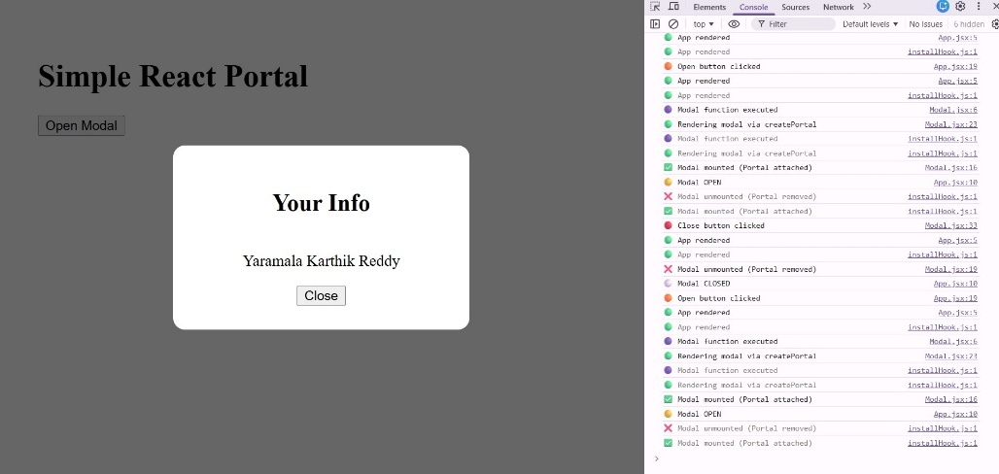
2.Responsive NavBar
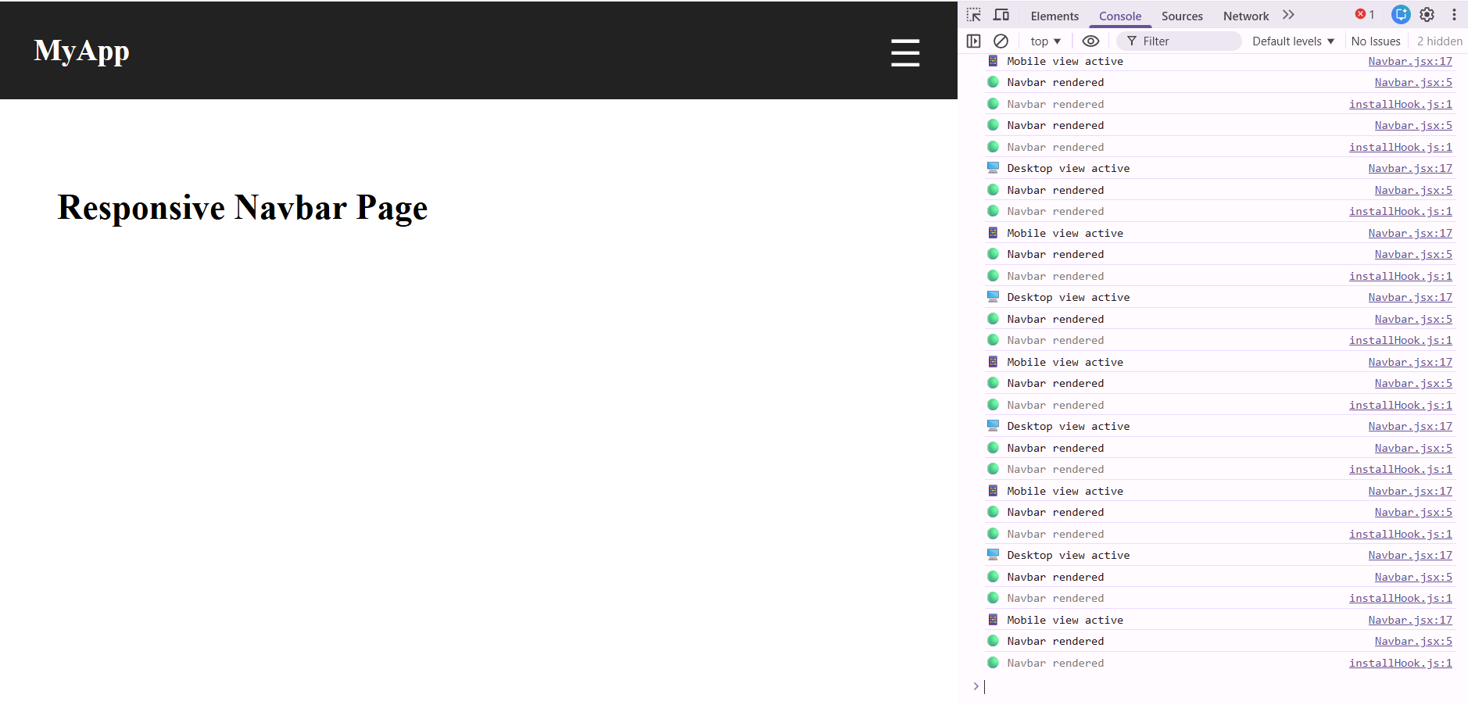
3.Theme Toggle:
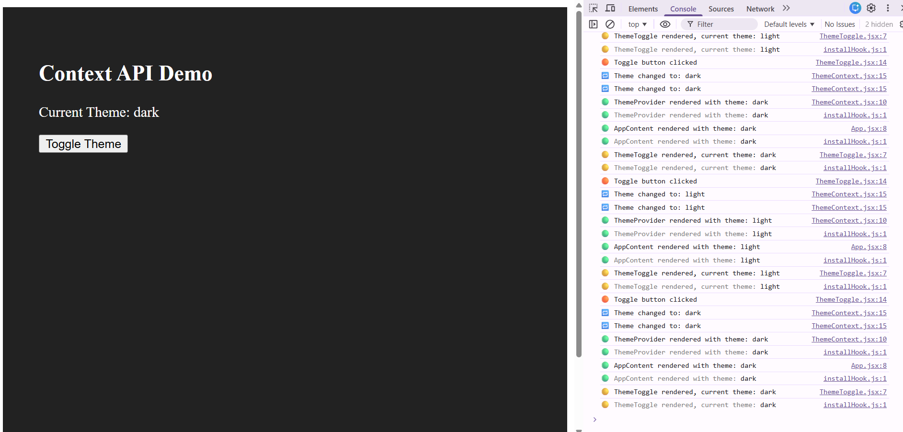
4.Drag and Drop:
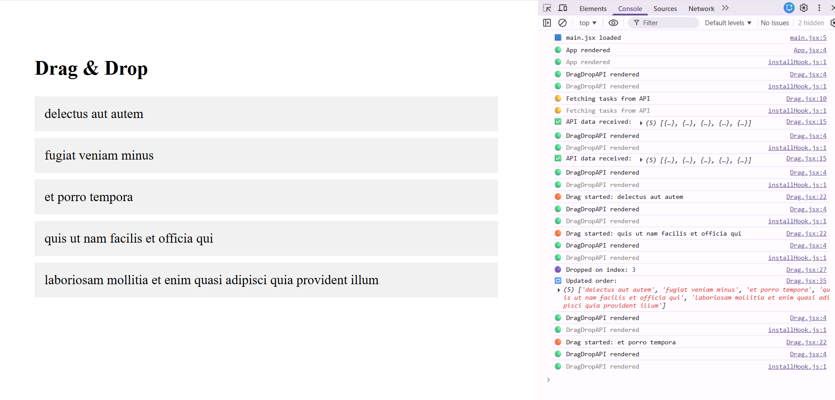
4.Cart Reduce:
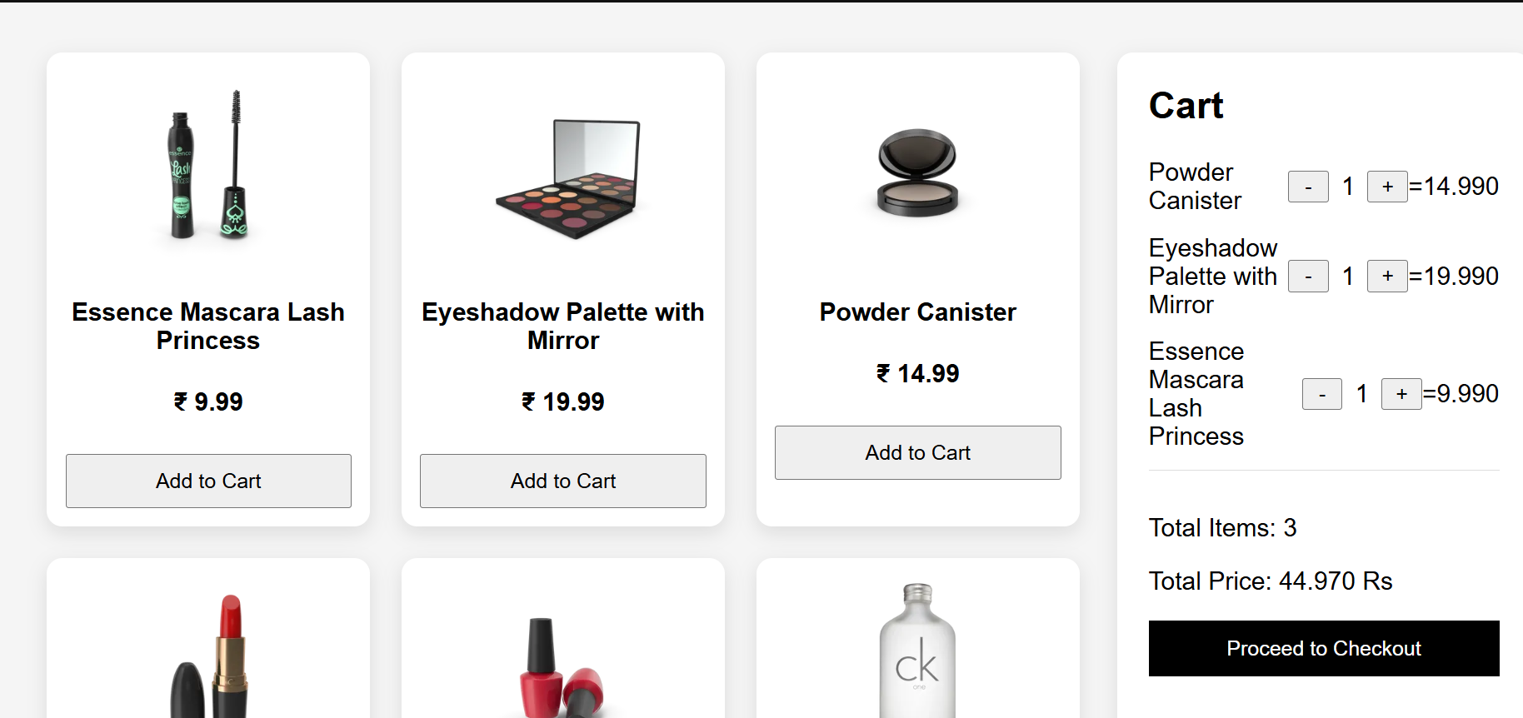
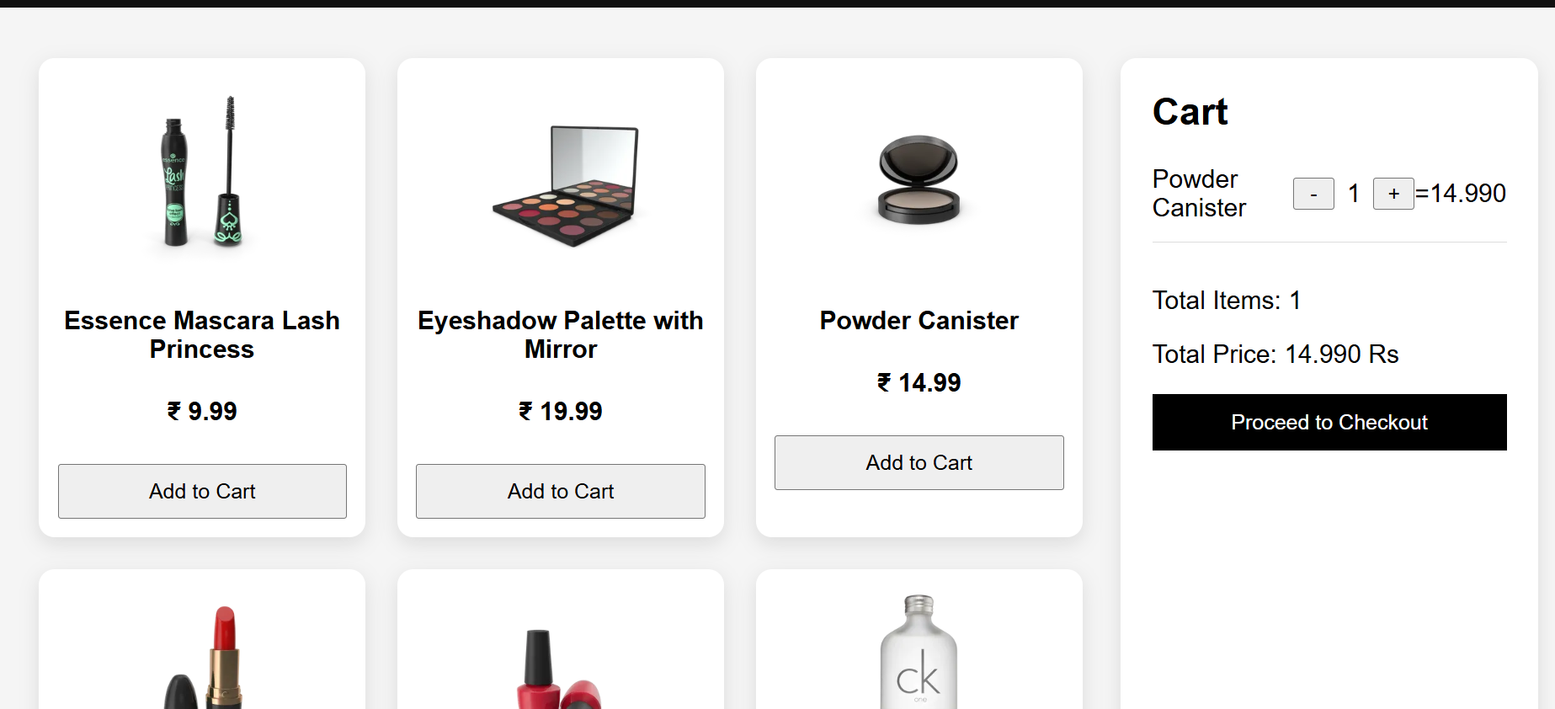
5.Whole Cart with Responsive UI:
